Packet Tracer – Configuring EIGRP Manual Summary Routes for IPv4 and IPv6

1. Topology

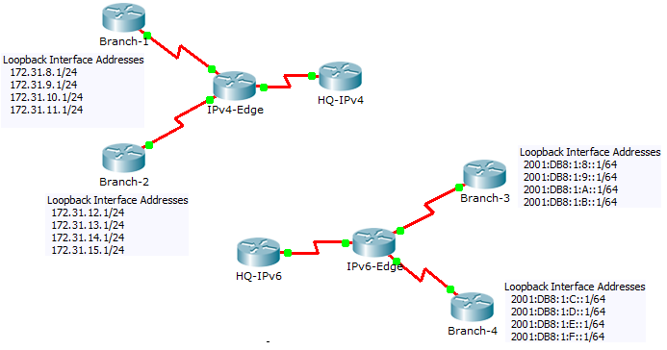

1. Addressing Table

|  |  |  |  |
| --- | --- | --- | --- |
| Device | Interface | IPv4 Address | Subnet Mask |
| IPv6 Address/Prefix | |
| HQ-IPv4 | S0/0/1 | 10.10.10.1 | 255.255.255.0 |
| IPv4-Edge | S0/0/0 | 172.31.6.1 | 255.255.255.0 |
| S0/0/1 | 172.31.7.1 | 255.255.255.0 |
| S0/1/0 | 10.10.10.2 | 255.255.255.0 |
| Branch-1 | S0/0/0 | 172.31.6.2 | 255.255.255.0 |
| Branch-2 | S0/0/1 | 172.31.7.2 | 255.255.255.0 |
| HQ-IPv6 | S0/0/1 | 2001:DB8:1:A001::1/64 | |
| IPv6-Edge | S0/0/0 | 2001:DB8:1:7::1/64 | |
| S0/0/1 | 2001:DB8:1:6::1/64 | |
| S0/1/0 | 2001:DB8:1:A001::2/164 | |
| Branch-3 | S0/0/0 | 2001:DB8:1:7::2/64 | |
| Branch-4 | S0/0/1 | 2001:DB8:1:6::2/64 | |

1. Objectives

Part 1: Configure EIGRP Manual Summary Routes for IPv4

Part 2: Configure EIGRP Manual Summary Routes for IPv6

1. Scenario

In this activity, you will calculate and configure summary routes for the IPv4 and IPv6 networks. EIGRP is already configured; however, you are required to configure IPv4 and IPv6 summary routes on the specified interfaces. EIGRP will replace the current routes with a more specific summary route thereby reducing the size of the routing tables.

1. Configure EIGRP Manual Summary Routes for IPv4
   1. Verify EIGRP configuration on each IPv4 enabled router.

Display the routing table on each IPv4 enabled router and verify that all IPv4 routes are visible. Ping the loopback interfaces from **HQ-IPv4** to verify connectivity.

* 1. Calculate, configure and verify a summary route on Branch-1.

By looking at the routing table on **IPv4-Edge**, verify that **Branch-1** is advertising all four networks represented by the loopback interfaces.

* + 1. Calculate a summary address for the four loopback interfaces on **Branch-1**.
    2. Configure **Branch-1** to advertise an EIGRP summary route to **IPv4-Edge**.
    3. Verify that **IPv4-Edge** now only has one summary route for all four loopback networks on **Branch-1**.
  1. Calculate, configure and verify a summary route on Branch-2.

By looking at the routing table on **IPv4-Edge**, verify that **Branch-2** is advertising all four networks represented by the loopback interfaces.

* + 1. Calculate a summary address for the four loopback interfaces on **Branch-2**.
    2. Configure **Branch-2** to advertise an EIGRP summary route to **IPv4-Edge**.
    3. Verify that **IPv4-Edge** now only has one summary route for all four loopback networks on **Branch-2**.
  1. Calculate, configure and verify a summary route on IPv4-Edge.

Although **HQ-IPv4** has two routes that represent the eight loopback networks, these two routes can be summarized into one route.

* + 1. Calculate a summary address for the two summary routes in **IPv4-Edge’s** routing table.
    2. Configure **IPv4-Edge** to advertise an EIGRP summary route to **HQ-IPv4**.
    3. Verify that **HQ-IPv4** now has only one summary route representing the eight loopback networks on Branch-1 and Branch-2.

**Note:** It may be necessary to reset the interface linking **HQ-IPv4** to **IPv4-Edge**.

* + 1. You should be able to ping all the IPv4 loopback interfaces from **HQ-IPv4**.

1. Configure EIGRP Manual Summary Routes for IPv6
   1. Verify EIGRP configuration on each IPv6 enabled router.

Display the routing table on each IPv6 enabled router and verify that all IPv6 routes are visible. Ping the loopback interfaces from **HQ-IPv6** to verify connectivity.

* 1. Calculate, configure and verify a summary route on Branch-3.

By looking at the routing table on **IPv6-Edge**, verify that **Branch-3** is advertising all four networks represented by the loopback interfaces.

* + 1. Calculate a summary address for the four loopback interfaces on **Branch-3**.
    2. Configure **Branch-3** to advertise an EIGRP summary route to **IPv6-Edge**.
    3. Verify that **IPv6-Edge** now only has one summary route for all four loopback networks on **Branch-3**.

**Note:** Packet Tracer does not currently grade EIGRP for IPv6 summary routes. However, the **IPv6-Edge** router should now only have five EIGRP routes, one of which is the summary you configured on **Branch-3**.

* 1. Calculate, configure and verify a summary route on Branch-4.

By looking at the routing table on **IPv6-Edge**, verify that **Branch-4** is advertising all four networks represented by the loopback interfaces.

* + 1. Calculate a summary address for the four loopback interfaces on **Branch-4**.
    2. Configure **Branch-4** to advertise an EIGRP summary route to **IPv6-Edge**.
    3. Verify that **IPv6-Edge** now only has one summary route for all four loopback networks on **Branch-4**.

**Note:** Packet Tracer does not currently grade EIGRP for IPv6 summary routes. However, the **IPv6-Edge** router should now only have two EIGRP routes, one summary route from each of the IPv6 branch routers.

* 1. Calculate, configure and verify a summary route on IPv6-Edge.

Although **HQ-IPv6** has two routes that represent the eight loopback networks, these two routes can be summarized into one route.

* + 1. Calculate a summary address for the two summary routes in **IPv6-Edge’s** routing table.
    2. Configure **IPv6-Edge** to advertise an EIGRP summary route to **HQ-IPv6**.
    3. Verify that **HQ-IPv6** now only has one summary route representing the eight loopback networks on **Branch-3** and **Branch-4**..

**Note:** It may be necessary to reset the interface linking **HQ-IPv6** to **IPv6-Edge**.

* + 1. You should be able to ping all the IPv6 loopback interfaces from **HQ-IPv6**.

1. Suggested Scoring Rubric

|  |  |  |  |
| --- | --- | --- | --- |
| Activity Section | Question Location | Possible Points | Earned Points |
| Part 2: Configure EIGRP Manual Summary Routes for IPv6 | Step 2 | 20 |  |
| Step 3 | 20 |  |
| Step 4 | 10 |  |
| **Part 2 Total** | | **50** |  |
| **Packet Tracer Score** | | **50** |  |
| **Total Score** | | **100** |  |